Create a PHP-MySQL web app in Azure App Service and deploy using FTP

This tutorial shows you how to create a PHP-MySQL web app and how to deploy it using FTP. This tutorial assumes you have [PHP](http://www.php.net/manual/en/install.php), [MySQL](http://dev.mysql.com/doc/refman/5.6/en/installing.html), a web server, and an FTP client installed on your computer. The instructions in this tutorial can be followed on any operating system, including Windows, Mac, and Linux. Upon completing this guide, you will have a PHP/MySQL web app running in Azure.

You will learn:

* How to create a web app and a MySQL database using the Azure Portal. Because PHP is enabled in Web Apps by default, nothing special is required to run your PHP code.
* How to publish your application to Azure using FTP.

By following this tutorial, you will build a simple registration web app in PHP. The application will be hosted in a Web App. A screenshot of the completed application is below:

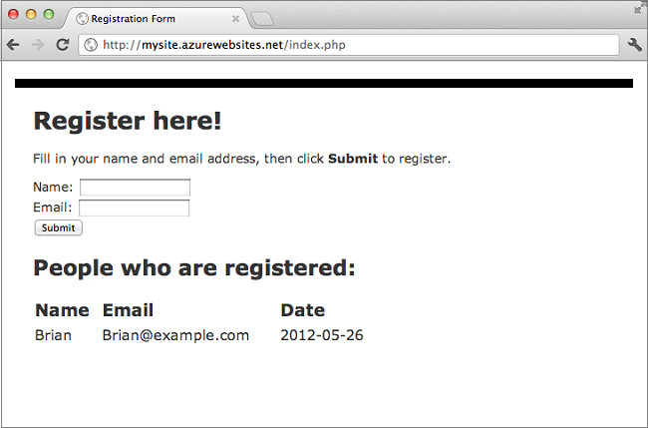

NOTE:

If you want to get started with Azure App Service before signing up for an account, go to [Try App Service](http://go.microsoft.com/fwlink/?LinkId=523751), where you can immediately create a short-lived starter web app in App Service. No credit cards required, no commitments.

Create a web app and set up FTP publishing

Follow these steps to create a web app and a MySQL database:

1. Login to the [Azure Portal](https://portal.azure.com/).
2. Click the **+ New** icon on the bottom left of the portal.

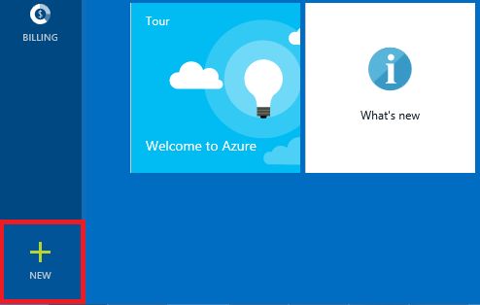

1. Click **Web + Mobile**, then **Web app + MySQL**.

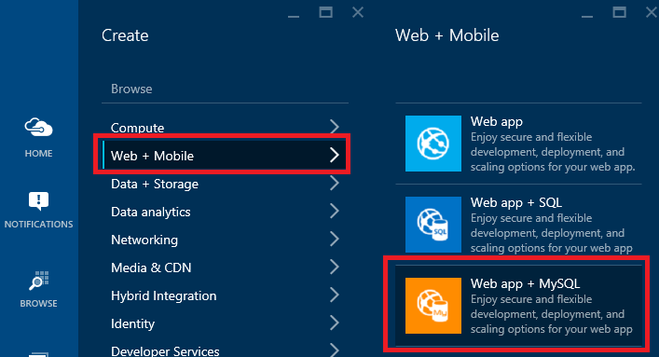

1. Enter a valid name for your resource group.

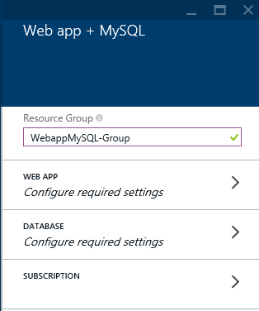

1. Enter values for your new web app.

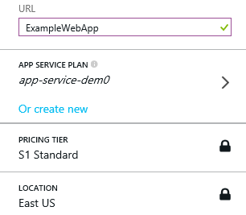

1. Enter values for your new database, including agreeing to the legal terms.

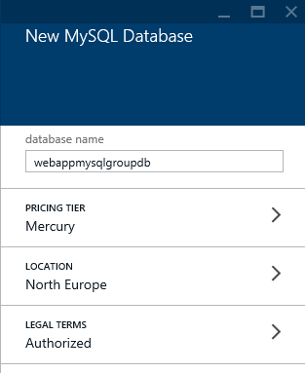

1. When the web app has been created, you will see the new resource group. Click the name of the web app to configure its settings.

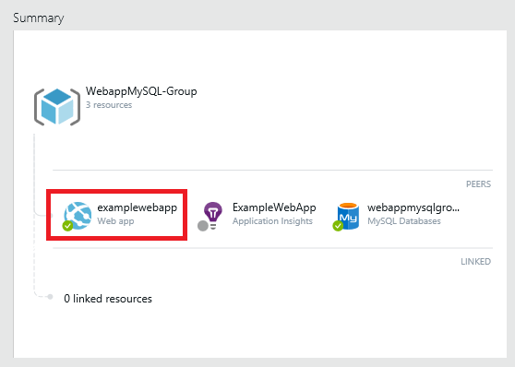

1. Scroll down until you find **Set deployment credentials**.

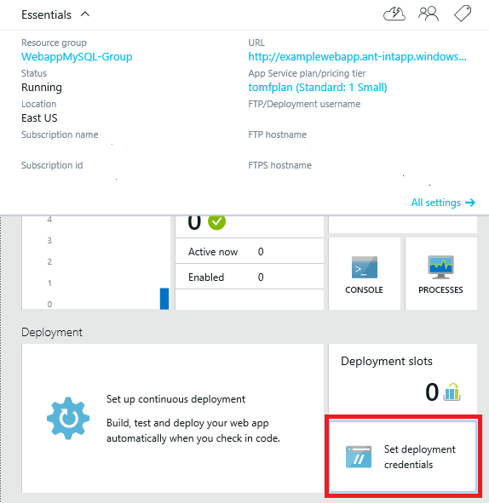

1. To enable FTP publishing, you must provide a user name and password. Save the credentials and make a note of the user name and password you create.

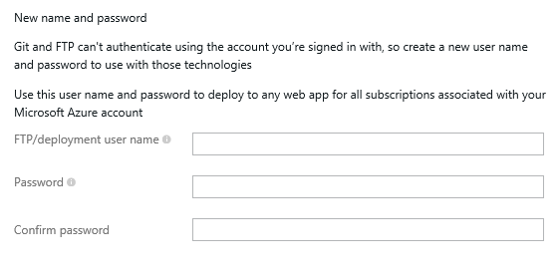

Build and test your app locally

The Registration application is a simple PHP application that allows you to register for an event by providing your name and email address. Information about previous registrants is displayed in a table. Registration information is stored in a MySQL database. The app consists of two files:

* **index.php**: Displays a form for registration and a table containing registrant information.
* **createtable.php**: Creates the MySQL table for the application. This file will only be used once.

To build and run the app locally, follow the steps below. Note that these steps assume you have PHP, MySQL, and a web server set up on your local machine, and that you have enabled the [PDO extension for MySQL](http://www.php.net/manual/en/ref.pdo-mysql.php).

1. Create a MySQL database called registration. You can do this from the MySQL command prompt with this command:

Copy to clipboardCopy

mysql> create database registration;

1. In your web server's root directory, create a folder called registration and create two files in it - one called createtable.php and one called index.php.
2. Open the createtable.php file in a text editor or IDE and add the code below. This code will be used to create the registration_tbl table in the registration database.

Copy to clipboardCopy

<?php

// DB connection info

$host = "localhost";

$user = "user name";

$pwd = "password";

$db = "registration";

try{

$conn = new PDO( "mysql:host=$host;dbname=$db", $user, $pwd);

$conn->setAttribute( PDO::ATTR_ERRMODE, PDO::ERRMODE_EXCEPTION );

$sql = "CREATE TABLE registration_tbl(

id INT NOT NULL AUTO_INCREMENT,

PRIMARY KEY(id),

name VARCHAR(30),

email VARCHAR(30),

date DATE)";

$conn->query($sql);

}

catch(Exception $e){

die(print_r($e));

}

echo "<h3>Table created.</h3>";

?>

NOTE:

You will need to update the values for $user and $pwd with your local MySQL user name and password.

1. Open a web browser and browse to [http://localhost/registration/createtable.php](http://localhost/tasklist/createtable.php). This will create the registration_tbl table in the database.
2. Open the **index.php** file in a text editor or IDE and add the basic HTML and CSS code for the page (the PHP code will be added in later steps).

Copy to clipboardCopy

<html>

<head>

<Title>Registration Form</Title>

<style type="text/css">

body { background-color: #fff; border-top: solid 10px #000;

color: #333; font-size: .85em; margin: 20; padding: 20;

font-family: "Segoe UI", Verdana, Helvetica, Sans-Serif;

}

h1, h2, h3,{ color: #000; margin-bottom: 0; padding-bottom: 0; }

h1 { font-size: 2em; }

h2 { font-size: 1.75em; }

h3 { font-size: 1.2em; }

table { margin-top: 0.75em; }

th { font-size: 1.2em; text-align: left; border: none; padding-left: 0; }

td { padding: 0.25em 2em 0.25em 0em; border: 0 none; }

</style>

</head>

<body>

<h1>Register here!</h1>

<p>Fill in your name and email address, then click <strong>Submit</strong> to register.</p>

<form method="post" action="index.php" enctype="multipart/form-data" >

Name <input type="text" name="name" id="name"/></br>

Email <input type="text" name="email" id="email"/></br>

<input type="submit" name="submit" value="Submit" />

</form>

<?php

?>

</body>

</html>

1. Within the PHP tags, add PHP code for connecting to the database.

Copy to clipboardCopy

// DB connection info

$host = "localhost";

$user = "user name";

$pwd = "password";

$db = "registration";

// Connect to database.

try {

$conn = new PDO( "mysql:host=$host;dbname=$db", $user, $pwd);

$conn->setAttribute( PDO::ATTR_ERRMODE, PDO::ERRMODE_EXCEPTION );

}

catch(Exception $e){

die(var_dump($e));

}

NOTE:

Again, you will need to update the values for $user and $pwd with your local MySQL user name and password.

1. Following the database connection code, add code for inserting registration information into the database.

Copy to clipboardCopy

if(!empty($_POST)) {

try {

$name = $_POST['name'];

$email = $_POST['email'];

$date = date("Y-m-d");

// Insert data

$sql_insert = "INSERT INTO registration_tbl (name, email, date)

VALUES (?,?,?)";

$stmt = $conn->prepare($sql_insert);

$stmt->bindValue(1, $name);

$stmt->bindValue(2, $email);

$stmt->bindValue(3, $date);

$stmt->execute();

}

catch(Exception $e) {

die(var_dump($e));

}

echo "<h3>Your're registered!</h3>";

}

1. Finally, following the code above, add code for retrieving data from the database.

Copy to clipboardCopy

$sql_select = "SELECT * FROM registration_tbl";

$stmt = $conn->query($sql_select);

$registrants = $stmt->fetchAll();

if(count($registrants) > 0) {

echo "<h2>People who are registered:</h2>";

echo "<table>";

echo "<tr><th>Name</th>";

echo "<th>Email</th>";

echo "<th>Date</th></tr>";

foreach($registrants as $registrant) {

echo "<tr><td>".$registrant['name']."</td>";

echo "<td>".$registrant['email']."</td>";

echo "<td>".$registrant['date']."</td></tr>";

}

echo "</table>";

} else {

echo "<h3>No one is currently registered.</h3>";

}

You can now browse to [http://localhost/registration/index.php](http://localhost/tasklist/index.php) to test the app.

Get MySQL and FTP connection information

To connect to the MySQL database that is running in Web Apps, your will need the connection information. To get MySQL connection information, follow these steps:

1. From your resource group, click the database:

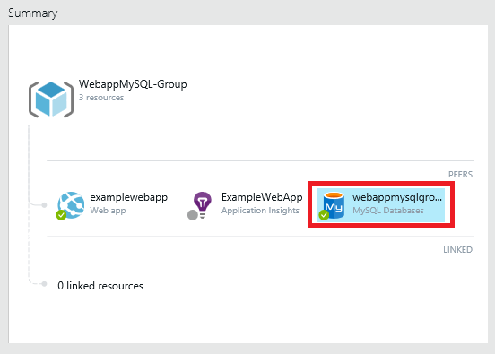

1. From the database sumamry, select **Properties**.

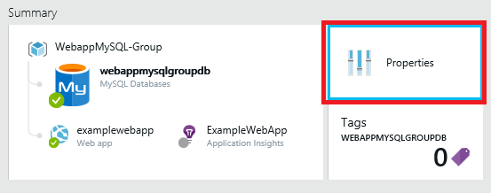

1. Make note of the values for Database, Host, User Id, and Password.

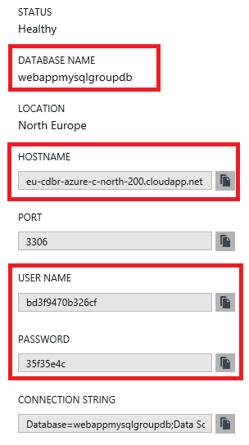

1. From your web app, click the **Download publish profile** link at the bottom right corner of the page:

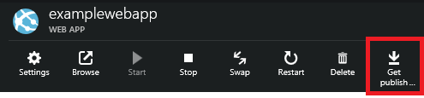

1. Open the .publishsettings file in an XML editor.
2. Find the <publishProfile > element with publishMethod="FTP" that looks similar to this:

Copy to clipboardCopy

<publishProfile publishMethod="FTP" publishUrl="ftp://[mysite].azurewebsites.net/site/wwwroot" ftpPassiveMode="True" userName="[username]" userPWD="[password]" destinationAppUrl="http://[name].antdf0.antares-test.windows-int.net"

...

</publishProfile>

Make note of the publishUrl, userName, and userPWD attributes.

Publish your app

After you have tested your app locally, you can publish it to your web app using FTP. However, you first need to update the database connection information in the application. Using the database connection information you obtained earlier (in the **Get MySQL and FTP connection information** section), update the following information in **both** the createdatabase.php and index.php files with the appropriate values:

Copy to clipboardCopy

// DB connection info

$host = "value of Data Source";

$user = "value of User Id";

$pwd = "value of Password";

$db = "value of Database";

Now you are ready to publish your app using FTP.

1. Open your FTP client of choice.
2. Enter the *host name portion* from the publishUrl attribute you noted above into your FTP client.
3. Enter the userName and userPWD attributes you noted above unchanged into your FTP client.
4. Establish a connection.

After you have connected you will be able to upload and download files as needed. Be sure that you are uploading files to the root directory, which is /site/wwwroot.

After uploading both index.php and createtable.php, browse to **http://[site name].azurewebsites.net/createtable.php** to create the MySQL table for the application, then browse to **http://[site name].azurewebsites.net/index.php** to begin using the application.